LICENSE AGREEMENT FOR ALLOTMENT GARDEN

THIS LICENSE AGREEMENT FOR ALLOTMENT GARDEN (“Agreement”) is made and entered into as of the ____ day of ________________, 2017 (the “Effective Date”), by and between THE CITY OF ATLANTA, a municipal corporation organized pursuant to the laws of the State of Georgia (“Licensor”) and GROUNDWORK ATLANTA, INC., a Georgia non-profit corporation (“Licensee”).

W I T N E S S E T H:

WHEREAS, Licensee is a non-profit organization whose work includes promoting urban agriculture in marginalized communities in the City of Atlanta area; and

WHEREAS, pursuant to a separate lease agreement between Georgia Power Company and Licensor dated ___________ (“GA Power Lease”), Licensor leases certain real property north of Spink Street, being a portion of Fulton County Tax Parcel 17 0245 LL0034, lying and being in Land Lot 245 of the 17th District of Fulton County, Georgia, and certain real property north of Campbellton Rd. SW, being a portion of Fulton County Tax Parcel 14 016800050301, lying and being in Land Lot 168 of the 14th District of Fulton County, Georgia, as depicted on Exhibit “A” attached hereto and incorporated herein by this reference (the “Premises”); and

WHEREAS, in furtherance of its urban agriculture program, Licensor desires to allow Licensee and its Invitees to use the Premises to develop and use allotment gardens on the Premises (“Program”), as further described on Exhibit “B” attached hereto and incorporated herein by this reference; and

WHEREAS, Licensee has applied for and obtained from the City of Atlanta Office of Planning a Special Administrative Permit number _________, dated ___________, 2017 (the “SAP”), allowing Licensee to operate the Program and setting forth certain parameters for the same, and Licensee has paid all permitting fees associated therewith; and

WHEREAS, Licensor desires to grant to Licensee, and Licensee desires to accept, a non-exclusive, temporary license to use the Premises, subject to the terms and conditions contained herein, and subject to the terms and conditions contained in the GA Power Lease, attached hereto as Exhibit “C” and incorporated herein by this reference.

NOW THEREFORE, for and in consideration of the premises and the covenants and agreements contained herein and other good and valuable consideration, the receipt and sufficiency of which are hereby acknowledged, and incorporating the foregoing recitals into this Agreement, Licensor and Licensee covenant and agree as follows:

- DEFINITIONS. In addition to the other terms defined elsewhere in this Agreement, each of the following terms shall have the meaning set forth below:

“Invitees”: Licensee’s employees, agents, servants, assignees, customers, visitors, concessionaires, contractors and subcontractors, allotment gardeners and any other participants in the Program.

“Law(s)”: All ordinances, statutes, orders, regulations, directives, rules and requirements of all federal, state, county, city or other governmental, public or quasi-public authorities, bodies, boards or agencies or any departments or bureaus thereof, now existing or hereafter created, which apply to Licensee or the use of the Premises or both, including but not limited to the requirements in City of Atlanta Code of Ordinances Section 16-29.001(83).

- LICENSE OF PREMISES; NO PROPERTY INTEREST. Licensor hereby grants to Licensee, and Licensee hereby accepts from Licensor, a non-exclusive license to use the Premises for $1 per year for the limited purposes outlined in this Agreement, and for no other purpose whatsoever. Such use by Licensee shall be in compliance with this Agreement, the GA Power Lease, and all applicable Laws. Licensee acknowledges that this Agreement does not create a lease, sublease, leasehold, subleasehold, or any other property right or interest in the Premises. Licensee agrees and acknowledges that this Agreement will in all respects be deemed a “license” and that upon the expiration or sooner termination of this Agreement or the GA Power Lease, Licensor may remove Licensee, its Invitees, and any property of Licensee or its Invitees from the Premises without need for or resort to any judicial process.

- TERM; TERMINATION.

3.1 Term. The term of this Agreement will begin on the Effective Date and continue in effect for five (5) years commencing on the ____ day of ____________, 20___, and ending at 12:00 midnight on the ____ day of ____________, 20____, unless sooner terminated or renewed as provided herein. Licensor, in its sole discretion, shall have the right to renew this Agreement for two (2) additional periods of three (3) years each upon the same terms and conditions set forth herein (such renewal periods, together with the initial five-year term, are collectively referred to herein as the “Term”). In the event that the SAP expires during the Term, Licensee shall not operate the Program or use the Premises until it has applied for and obtained a new SAP.

3.2 Right to Terminate. Licensor has the right to terminate this Agreement prior to the expiration of the Term for any reason or no reason whatsoever, including for the convenience of Licensor, by giving three (3) days’ written notice to Licensee. Licensor reserves the right to terminate this Agreement without such notice in the event that the GA Power Lease is immediately terminated.

- PERMITTED USE; PROHIBITED USES.

  - Permitted Use. Licensee shall use the Premises solely for the Program, and for no other purpose whatsoever.
  - Prohibited Uses.
    - Licensee shall not do, or permit its Invitees to do, in or about the Premises, nor shall Licensee bring or keep or permit its Invitees to bring or keep therein, anything which is prohibited by or will in any way conflict with any Laws now in force or which may hereafter be enacted or promulgated, or will in any way increase the existing rate of or affect any insurance upon the Premises or cause a cancellation of any insurance policy covering the Premises or which impairs or adversely affects the character, reputation or appearance of the Premises.

    - Licensee shall not use, or allow its Invitees to use, the Premises for any improper, immoral, unlawful or objectionable purpose.

    - Licensee shall not cause or maintain, or permit its Invitees to cause or maintain, any nuisance in, on or about the Premises or commit or suffer to be committed any waste in, on or about the Premises.

    - Licensee shall not use, or permit its Invitees to use, the Premises for any activity that produces any noise or sound that is objectionable due to intermittence, beat, frequency, vibration, shrillness or loudness; noxious odor; noxious, toxic, caustic or corrosive fuel or gas; dust, dirt or fly ash in excessive quantities; or fire, explosion or other damaging or dangerous hazard, including the storage, display or sale of explosives or fireworks.

    - Licensee shall not engage in, and shall not permit its Invitees to engage in, any sale or merchandising on the Premises.

- REPRESENTATIONS AND WARRANTIES. Licensee represents and warrants to Licensor as of the Effective Date as follows:

5.1 Business Licenses and Permits. Licensee possesses all applicable business licenses and permits required by all applicable Laws.

5.2 Condition of Premises. Licensee accepts the Premises in their “AS-IS”, “WHERE-IS”, and “WITH ALL FAULTS” condition on the date hereof and specifically and expressly without any warranties, representations, or guaranties, either express or implied, of any kind, nature, or type whatsoever from or on behalf of Licensor, including without limitation, any warranty of condition, merchantability or fitness for a particular use. Licensee further acknowledges that Licensor does not guarantee or warrant the safety and security of the Premises, and Licensee and its Invitees are responsible for their own safety and security.

5.3 GA Power Lease. Licensee represents and warrants that Licensee has read the GA Power Lease and is familiar with the terms and conditions thereof. As set forth below, Licensee agrees and acknowledges that any act or omission of Licensee that would be deemed an event of default under the GA Power Lease shall be an event of default under this License.

5.4 Independent Contractual Obligations of Licensee. Licensor is not a party to and has no liability with respect to any agreement between Licensee and a third party for products, services or otherwise.

- COVENANTS. Licensee hereby covenants and agrees as follows:

  - Licensee shall at all times during the Term maintain and keep current all business licenses and permits required by applicable Laws.

  - Licensee shall not make any alterations, additions, or improvements to the Premises outside of the scope of the Program.

  - Licensee shall comply with all Laws regarding the use and occupancy of the Premises. Licensee shall comply with all requirements of the SAP relating to the use of the Premises. Licensee agrees to perform and comply with, for the benefit of Licensor and Georgia Power Company, the obligations of Licensor as tenant under the GA Power Lease which pertain to the Premises and/or this License, except for those provisions of the GA Power Lease which are directly contradicted by this License, in which event the terms of this License shall control over the GA Power Lease. The terms of the GA Power Lease are incorporated herein by this reference as if fully set forth herein. Licensee agrees not to do or perform any act or omission that would be deemed an event of default under the GA Power Lease, or render Licensor liable for any damage, charge or expense thereunder. Licensee will indemnify, defend, protect and hold Licensor harmless from and against any loss, cost, damage or liability (including attorneys’ fees) of any kind or nature arising out of, by reason of, or resulting from, Licensee’s failure to perform or observe any of the terms and conditions of the GA Power Lease or this License.

  - Licensee shall not vacate or abandon the Premises prior to the expiration or sooner termination of the Term.

  - Licensee shall require all Invitees to enter into a gardener agreement and waiver of liability substantially in the form attached hereto as Exhibit “D” and incorporated herein by this reference (“Gardener Waiver”). Licensee shall provide copies of all executed Gardener Waivers to Licensor.

  - Licensee shall provide notice to Licensor of any notices posted at the Premises and of any notices provided to Licensee by Georgia Power Company or its agents or employees regarding the Premises, including but not limited to eviction notice posted at the Premises or provided to Licensee.

- MATERIALS AND EQUIPMENT; UTILITIES. Licensee is responsible for providing all equipment and materials necessary or desirable for Licensee and its Invitees to conduct and participate in the Program at the Premises, all at Licensee’s sole cost and expense. Licensee shall ensure that all equipment, when not in use, shall be stored so as not to be visible from any public street, sidewalk, or right-of-way. Licensee will have sole responsibility for obtaining and paying for all water, electricity, heat, sewage, storm sewer, or any other utility service used on the Premises during the Term.
- LICENSOR’S RIGHT OF ENTRY. Licensor shall have the right to use and enter the Premises at any time during the Term of this Agreement to inspect the Premises and ensure compliance with the GA Power Lease. This Paragraph does not impose any duty on Licensor to inspect the Premises, report to Licensee the results of any inspection or assume any liability of any kind arising from inspecting or not inspecting the Premises. Licensor shall have no obligation to make any alterations, improvements or repairs to the Premises of any kind, or to provide any services or other support to Licensee.

- RISK OF LOSS. All property located in or about the Premises belonging to Licensee or any Invitee of Licensee shall be at the sole risk of Licensee and any Invitee of Licensee. Licensor is not responsible for lost, damaged or stolen property. Licensor is not responsible for damage or injury to Licensee or any Invitee of Licensee or their respective property caused by fire, water, snow, frost, steam, heat, cold, dampness, sewers or sewage, gas, odor, noise, the bursting or leaking of pipes, plumbing, electrical wiring or equipment or fixtures of any kind, or by any act or neglect of any other person.

- INDEMNITY; INSURANCE AND WAIVER OF SUBROGATION.

10.1 Indemnity. Licensee hereby releases and shall indemnify, defend, and hold harmless Licensor, its elected officials, officers, agents, employees, representatives, successors, and assigns from and against any and all suits, actions, legal or administrative proceedings, claims, debts, demands, damages, obligations, losses, judgments, charges, interest, attorneys’ fees, costs, causes of action of every kind and character, whether in law or equity, and expenses of every kind, whether arising before or after the expiration or termination of this Agreement and in any manner directly or indirectly caused, occasioned, or contributed to in whole or in part, by reason of any act, omission, fault or negligence of Licensee, its officers, employees, agents, subcontractors, Invitees or of anyone acting under its direction or control or on its behalf in connection with or incidental to this Agreement. This indemnification and hold harmless provision shall survive any expiration or termination of this Agreement.

10.2 Insurance. Licensor has no obligation to carry insurance on, and will not be responsible for damage to, the Premises or any of Licensee’s property or that of any Invitees. To the extent permitted by applicable Laws, Licensor reserves the right to adjust any insurance requirements for Licensee contained in this Agreement.

10.2.1 Evidence of Insurance Required Before Term Commences. No use or occupancy under the Agreement may be commenced until all insurance requirements contained herein, or required by applicable Laws, have been complied with by Licensee and evidence of such compliance satisfactory to Licensor as to form and content has been provided to Licensor. Licensee must provide Licensor with a Certificate of Insurance that clearly and unconditionally indicates that Licensee has complied with all insurance requirements set forth in this Agreement.

10.2.2 Minimum Financial Security Requirements. All companies providing insurance required by this Agreement must meet certain minimum financial security requirements. These requirements must conform to the ratings published by A.M. Best & Co. in the current Best's Key Rating Guide - Property-Casualty. The ratings for each company must be indicated on the documentation provided by Licensee to Licensor certifying that all insurance requirements set forth in this Agreement have been unconditionally satisfied. Companies providing insurance under the Agreement must meet the following requirements:

i) Best's Rating not less than A-,
ii) Best's Financial Size Category not less than Class VII, and
- Companies must be authorized to conduct and transact insurance contracts by the Insurance Commissioner, State of Georgia.

If the issuing company does not meet these minimum requirements, or for any other reason is or becomes unsatisfactory to Licensor, Licensor will notify Licensee in writing, and Licensee must promptly obtain a new policy or bond issued by an insurer acceptable to Licensor and submit to Licensor evidence of its compliance with these conditions.

10.2.3 No Waiver of Liability or Indemnification. Licensee’s failure to comply with all insurance requirements set forth in this Agreement will not relieve Licensee from any liability under the Agreement. Licensee’s obligations to comply with all insurance requirements set forth in this Agreement will not be construed to conflict with or limit Licensee’s indemnification obligations under the Agreement.

10.2.4 Insurance Required for Entire Term of Agreement. All insurance required by this Agreement must be maintained during the entire Term.

10.2.5 Notices of Cancellation & Renewal. Licensee must notify Licensor in writing at the address listed below by mail, hand-delivery or facsimile transmission, within 2 days of any notices received from any insurance carriers providing insurance coverage under this Agreement that concern the proposed cancellation or termination of coverage.

City of Atlanta
Enterprise Risk Management
68 Mitchell St. SW, Suite 9100
Atlanta, GA 30303
Facsimile No. (404) 658-7450
Confirmation of any mailed notices must be evidenced by return receipts of registered or certified mail. Licensee shall provide the Licensor with evidence of required insurance prior to the commencement of this Agreement, and, thereafter, with a certificate evidencing renewals or changes to required policies of insurance at least fifteen (15) days prior to the expiration of previously provided certificates.

10.2.6 Agent Acting as Authorized Representative. Each and every agent acting as authorized representative on behalf of a company affording coverage under this Agreement shall warrant when signing the accord certificate of insurance that specific authorization has been granted by the company for the agent to bind coverage as required and to execute the accord certificates of insurance as evidence of such coverage. Licensor’s coverage requirements may be broader than the original policies; these requirements have been conveyed to the companies for these terms and conditions. In addition, each and every agent shall warrant when signing the accord certificate of insurance that the agent is licensed to do business in the State of Georgia and that the company or companies are currently in good standing in the State of Georgia.

10.2.7 Certificate Holder. Licensor must be named as certificate holder on all insurance required to be maintained by Licensee hereunder. All notices pertaining to such insurance must be mailed to the attention of City of Atlanta, Enterprise Risk Management at 68 Mitchell Street SW, Suite 9100, Atlanta, Georgia 30303.

10.2.8 Premises. The address of the Premises and name of Licensee must be referenced in the description section of the insurance certificate.

10.2.9 Additional Insured Endorsements Form CG 20 26 07 04 or equivalent. Licensor must be covered as an additional insureds under all insurance (except worker’s compensation and professional liability) required by this Agreement and such insurance must be primary with respect to the additional insureds. Licensee must submit to Licensor an additional insured endorsement evidencing Licensor’s rights as an additional insured for each policy of insurance under which it is required to be an additional insured pursuant to this Agreement. Endorsement must not exclude the additional insured from products - completed operations coverage. Licensor shall not have liability for any premiums charged for such coverage.

10.2.10 Self-Insured Retentions, Deductibles or Similar Obligations. Any self-insured retention, deductible or similar obligation will be the sole responsibility of Licensee.

10.2.11 Workers' Compensation and Employer's Liability Insurance. Licensee must procure and maintain Workers' Compensation and Employer's Liability Insurance in the following limits to cover each employee who is or may be engaged in work for Licensee:

Workers' Compensation. . . . . . . . Statutory (O.C.G.A. Title 34, Chapter 9)
Employer's Liability:
Bodily Injury by Accident/Disease $500,000 each accident
Bodily Injury by Accident/Disease $500,000 each employee
Bodily Injury by Accident/Disease $500,000 policy limit

Notwithstanding the foregoing, the requirements of this Section 10.2.11 shall not apply to any Licensee that employs fewer than three (3) regular employees, per O.C.G.A. § 34-9-2(a)(2).

10.2.12 Commercial General Liability Insurance. Licensee must procure and maintain Commercial General Liability Insurance on form (CG 00 00 01 or equivalent) in an amount not less than $1,000,000 per occurrence subject to a $2,000,000 aggregate. The following indicated extensions of coverage must be provided:

Contractual Liability
Broad Form Property Damage
Premises Operations
Personal Injury
Advertising Injury
Fire Legal Liability
Medical Expense
Independent Contractor/Consultants/Subcontractor/Consultants (if applicable)
Additional Insured Endorsement (primary & non-contributing in favor of Licensor and Georgia Power)
Waiver of Subrogation in favor of Licensor and Georgia Power

- DEFAULT BY LICENSEE; REMEDIES. If Licensee defaults in the performance of any of the terms, conditions, covenants, representations or provisions of this Agreement to be performed or observed by Licensee and does not remedy such default within three (3) days after written notice of such default from Licensor, then Licensor shall have the right to immediately terminate this Agreement without further notice to Licensee, and may remove all property of Licensee from the Premises and dispose of such property as it sees fit, all without resort to legal process and without being deemed guilty of trespass, or becoming liable for any loss or damage which may be occasioned thereby. Notwithstanding the foregoing or anything to the contrary contained in this Agreement, if Licensee defaults on more than two (2) occasions during the Term or if Licensee engages in any reckless, disruptive or dangerous behavior at the Premises as determined by Licensor in its sole discretion, then regardless of whether Licensee acts to remedy or cure the same, Licensor shall have the right to immediately terminate this Agreement without notice to Licensee, and may remove all property of Licensee from the Premises and dispose of such property as it sees fit, all without resort to legal process and without being deemed guilty of trespass, or becoming liable for any loss or damage which may be occasioned thereby. In the event of any termination by Licensor due to default of Licensee, Licensor may pursue all remedies available at law or in equity including without limitation the recovery from the Licensee of any damages, costs, and expenses incurred by reason of such breach, including, but not limited to, reasonable attorneys’ fees and court costs.

- VACATING PREMISES; ABANDONED PERSONAL PROPERTY.

12.1 Vacating the Premises. Upon the expiration or earlier termination of this Agreement, Licensee shall vacate and surrender the Premises and promptly remove all effects, personalty and equipment placed at the Premises by Licensee or its Invitees. Licensee shall completely repair, at Licensee’s expense, any and all damage to the Premises resulting from or caused by such placement or removal by restoring the Premises to at least as good a condition as existed at the commencement of the Term. The covenants and conditions of this Paragraph shall survive any expiration or termination of this Agreement.

12.2 Abandoned Personalty. If Licensee fails or refuses to remove its effects, personalty and equipment or that of its Invitees from the Premises upon the expiration or termination of this Agreement for any cause whatsoever, such effects, personalty and equipment shall be deemed conclusively to be abandoned and may be appropriated, sold, stored, destroyed or otherwise disposed of by Licensor without written notice to Licensee or any other party and without obligation to account for same. Licensee shall pay Licensor on demand any and all expenses incurred by Licensor in the removal of such property, including, without limitation, the cost of repairing any damage to the Premises caused by the removal of such property and all storage charges (if Licensor elects to store such property). Licensee shall not be entitled to receive any payment or reimbursement for the value of crops left behind or for any damage to crops or any other damages caused by or resulting from any termination or expiration of this License. The covenants and conditions of this Paragraph shall survive any expiration or termination of this Agreement.

- HOLDING OVER. If Licensee fails to vacate the Premises upon the expiration or earlier termination of this Agreement, such holding over shall, in the event of Licensor’s express written consent thereto, constitute a license from week to week, terminable on two (2) days’ notice. In the event that Licensor does not expressly consent in writing to Licensee’s holding over beyond the expiration or termination of this Agreement, then Licensee will be a tenant at sufferance and will owe Licensor compensation for the period of occupancy subsequent to such expiration or termination at the rate of $100.00 per day.

- NOTICES. All notices required or permitted to be given hereunder must be in writing and delivered (i) in person or by courier, (ii) by recognized national overnight delivery service, (iii) by U.S. Mail, certified, return receipt requested, postage prepaid, or (iv) by e-mail. Any such notice will be deemed received (i) in the case of personal delivery, recognized national overnight delivery service or courier delivery, on the date of delivery to such party, (ii) in the case of certified mail, the date receipt is acknowledged on the return receipt for such notice, (iii) if delivery is rejected or refused or the courier, overnight delivery service or U.S. Postal Service is unable to deliver same because of changed address of which no notice was given pursuant hereto, on the first date of such rejection, refusal or inability to deliver, or (iv) in the case of e-mail, on the date the e-mail is sent, provided that if such e-mail is sent on a non-business day or after 5:00 p.m. on a weekday, then notice shall be deemed received on the following business day. All such notices must be addressed to the parties at the addresses below or at such other address, as either party will have given to the other by notice as herein provided.

Licensee: Groundwork Atlanta, Inc.
Attn:
794 Marietta St. NW # 93955
Atlanta, GA 30318
email: groundworkatlanta@gmail.com

Licensor: Mario Cambardella
Office of the Mayor, Suite 2400
55 Trinity Avenue
Atlanta, Georgia 30303
e-mail:

With a copy to: City of Atlanta Department of Law
Attn: City Attorney
55 Trinity Avenue, Suite 5000
Atlanta, Georgia 30303
E-Mail: mpmcshane@AtlantaGa.Gov

- MISCELLANEOUS.

  - Entire Agreement. This Agreement and the Exhibits attached hereto contain the entire agreement of the parties hereto, and no other representations, inducements, promises or agreements between the parties, oral or otherwise, not embodied herein, will be of any force or effect. This Agreement may not be modified except by written agreement signed by the parties hereto. No consent or approval of Licensor will be effective for any purpose unless Licensor executes a written instrument setting forth such consent or approval.

  - Headings. The section headings in this Agreement are inserted only as a matter of convenience and are not to be given any effect whatsoever in construing this Agreement.

  - No Waiver. No failure of Licensor to exercise any power given Licensor hereunder, or to insist upon strict compliance by Licensee of Licensee’s obligations hereunder, and no custom or practice of the parties at variance with the terms hereof will constitute a waiver of Licensor’s right to demand strict compliance with the terms hereof.

  - No Recordation. Neither this Agreement nor any memorandum or short form thereof shall be recorded in any public records.

  - Applicable Law; Consent to Jurisdiction. This Agreement will be governed by and construed in accordance with the laws of the State of Georgia. Licensee hereby irrevocably agrees that any legal action or proceeding against Licensee with respect to this Agreement may be maintained in the courts of Fulton County or at Licensor’s option, in the U.S. District Court for the Northern District of Georgia; and Licensee hereby consents to the jurisdiction and venue of such courts.

  - Relationship of Parties. The parties acknowledge and agree that in no event will Licensor be construed or held by virtue of this Agreement OR OTHERWISE, to be an employer, agent, partner, associate or JOINT VENTURER of Licensee OR ITS INVITEES in the conduct of Licensee’s business OR THE PROGRAM, nor shall Licensor be liable for any debts OR LIABILITIES incurred by Licensee in the conduct of Licensee’s business OR THE PROGRAM. NEITHER LICENSEE NOR ANY INVITEE IS AN EMPLOYEE, INDEPENDENT CONTRACTOR, AGENT, PARTNER, ASSOCIATE OR JOINT VENTURER OF LICENSOR.

  - No Third-Party Beneficiaries. This Agreement is for the exclusive benefit of Licensor and Licensee, and not for the benefit of any third party including, without limitation, any Invitee of Licensor.

  - Successors and Assigns. Licensee shall not assign, mortgage, pledge, or otherwise encumber the Premises, this Agreement or any interest herein or any right or privilege appurtenant thereto. Licensee may not sublicense all or any portion of the Premises. Any assignment, mortgage or sublicense so made shall be null and void. The provisions of this Agreement will bind and inure to the benefit of Licensor and Licensee and their respective permitted successors, heirs, legal representatives, and assigns.

  - Severability. If any clause or provision of this Agreement is found by a court of competent jurisdiction to be illegal, invalid or unenforceable, then the unaffected terms shall remain in full force and effect.

  - Independent Covenants. Each covenant, agreement, obligation or other provision of this Agreement on Licensee’s part to be performed shall be deemed and construed as independent covenants of Licensee, not dependent on any other provisions of this Agreement.

  - Construction; Opportunity to Consult with Counsel. This Agreement shall be construed without regard to any presumption or other rule requiring construction against the party causing the Agreement to be drafted. Licensee has carefully read this Agreement and understands it. Licensee executes this Agreement as a voluntary act after having consulted with counsel of its choosing concerning the same, or having voluntarily chosen not to consult with counsel concerning the same.

  - Time of Essence. Time is of the essence in the performance of this Agreement and all covenants and provisions contained herein.

  - Counterparts; Facsimile Signatures. This Agreement may be executed in multiple counterparts, each of which shall be deemed an original, but all of which together shall constitute one and the same instrument. For purposes of this Agreement, any signature transmitted by facsimile or electronically via e-mail shall be considered to have the same legal and binding effect as any original signature.

  - Authority. Each individual executing this Agreement represents and warrants that he or she is duly authorized to execute this Agreement on behalf of Licensee, and that Licensee has full right and authority to execute and deliver this Agreement.

  - Exhibits. The following Exhibits are attached hereto and made a part of this Agreement by this reference:

Exhibit “A” – Depiction of Premises
Exhibit “B” – Program Description and Requirements
Exhibit “C” – GA Power Lease Agreement
Exhibit “D” – Gardener Agreement and Waiver of Liability Form

[SIGNATURES BEGIN ON FOLLOWING PAGE]

IN WITNESS WHEREOF, the parties hereto have executed this Agreement as of the Effective Date.

LICENSEE:

GROUNDWORK ATLANTA, INC.,

a Georgia non-profit corporation

By:_________________________

Name: ______________________

Title: _______________________

LICENSOR:

CITY OF ATLANTA

By:_________________________
Name:
Title:

ATTEST:

By:__________________________
MUNICIPAL CLERK (Seal)

APPROVED AS TO FORM:

By:___________________________
CITY ATTORNEY

Exhibit “A”
Premises

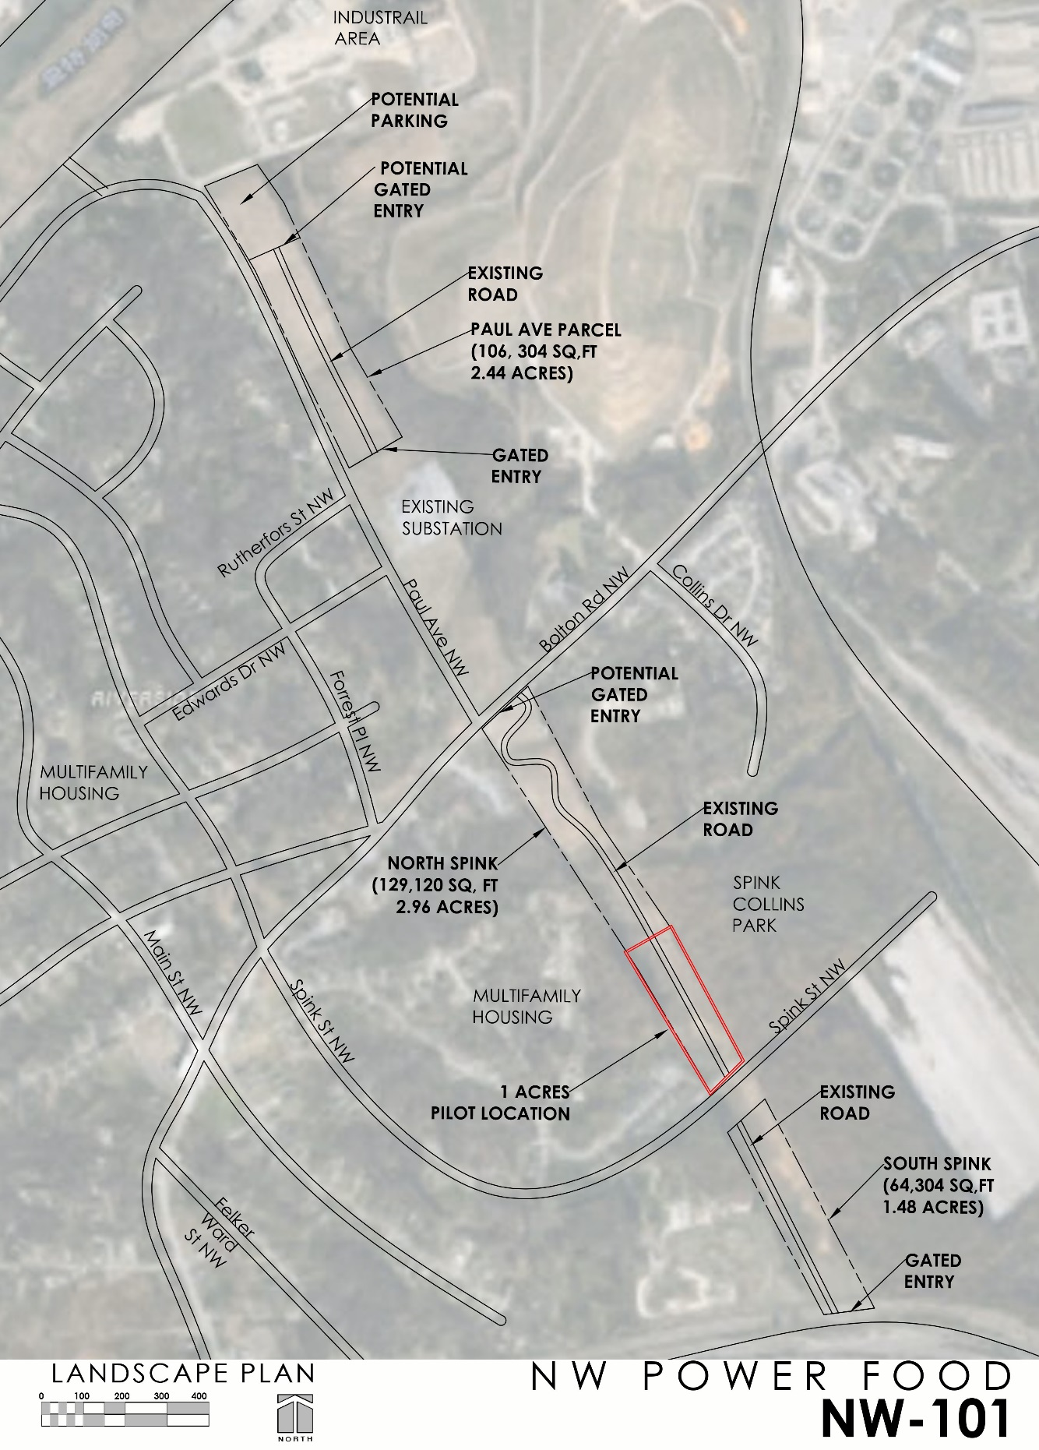
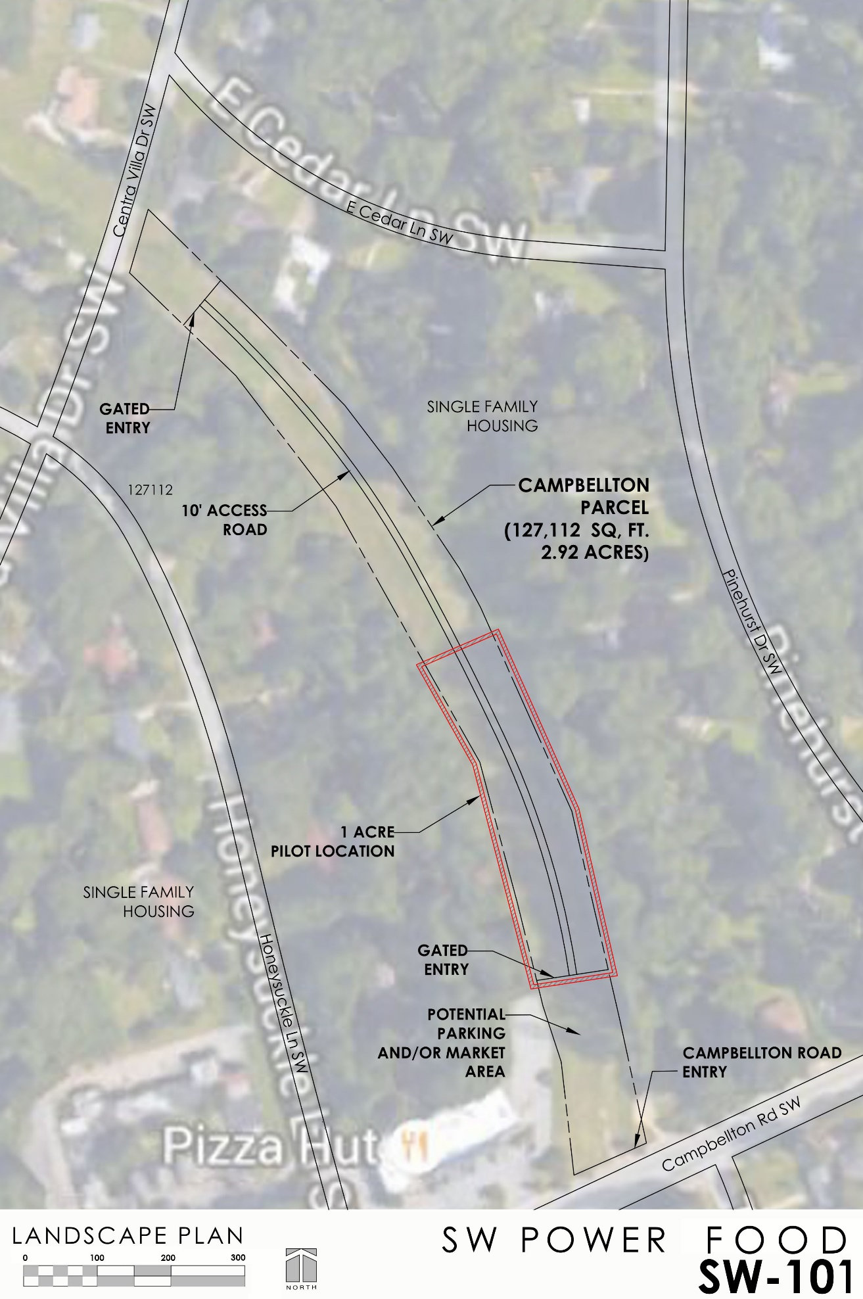
Exhibit “B”
PROGRAM DESCRIPTION AND REQUIREMENTS

- The Premises shall be used solely for gardening purposes and other approved related uses and shall serve as an educational resource and the production of locally grown food within the bounds of the City of Atlanta. Sustainable agriculture practices and infrastructure for composting, attracting pollinators and beneficial insects for ecological pest control are encouraged in the conduct of Gardener’s operations.

- Groundwork Atlanta (“GWA”) in coordination with and with support from the City of Atlanta (“City”) will perform an advertising and public engagement process during the development of the gardens, and other approved related uses on the Premises; administer any necessary requests for proposal in the selection of gardeners to operate the gardens; and engage in reasonable efforts to select Gardeners which follow best practices for gardening operations on the Premises.

- Any physical changes and other initiatives on the Premises shall be prepared and conducted by GWA, based on available funds and an approved public process. GWA shall comply with the City’s review and approval process. GWA shall comply with all terms and conditions of the SAP and the Urban Gardens Section 16-29.001(83) of the Zoning Ordinance. GWA shall be responsible for determining any and all other governmental bodies and/or regulatory agencies from which approval must be obtained, if any. GWA shall not begin work on the Program, these projects, improvements or other initiatives until it has successfully passed the City's review and approval process, the City has provided written approval of the same, and it has received written approval from any other governmental body or regulatory agency from which approval is required, if any.

- GWA shall comply with the Georgia Power Lease so that all physical changes and operations by allotment gardeners respect the primary use of the Premises.

- GWA agrees that all publicity emanating from GWA or its Invitees contains information that Georgia Power owns the Premises, and the City is a partner on this Project.

- GWA will provide a site plan for the allotment garden to both the City and Georgia Power.

- GWA and its Invitees will be permitted access to the Premises via a secure Georgia Power-owned gate 24 hours a day, 7 days a week.

- Vehicles will be permitted to be parked and stored within the Premises during standard operating hours.

- Farm equipment will be permitted to operate and be stored on the Premises in a manner that complies with GWA secondary use guidelines.

- Community and educational events shall be permitted on the Premises during the hours of 9 AM to 5 PM, on designated days, and in compliance with any necessary approvals of Georgia Power.

- The right to establish facilities for small farm husbandry for the entirety of the animal’s life shall be permitted.
Exhibit “C”
GA POWER LEASE AGREEMENT

Exhibit “D”
GARDENER AGREEMENT

This Agreement is entered between Groundwork Atlanta, Inc. (“GWA”) and _____________________ (“Gardener”) as of __________________, 2017.

- This Agreement shall govern Gardener’s use of certain premises (“Premises”) as described in the attached Exhibit __.

- The Premises shall be used solely for an allotment garden, and other approved related uses by Gardener pursuant to and consistent with a program sponsored by the City of Atlanta and GWA (“Program”).

- The Program is intended to serve as an educational resource as well as providing locally grown food. Sustainable agriculture practices and infrastructure for composting, attracting pollinators and beneficial insects for ecological pest control are mandated pursuant to this Program and must engage in a third-party verification program such as Certified Naturally Grown, USDA Organic, or approved equal by Groundwork staff.

- Gardener will be responsible for performing and providing at its own cost any improvements to the Premises consistent with the Program, including but not limited to any tilling of the soil, provision of any supplemental organic soil and mulch, construction of raised beds or the like. Any such improvements shall be subject to GWA’s and/or the City of Atlanta’s (“City”) following advance notice by Gardener of any such planned improvements. Similarly, Gardener shall be responsible for all costs relating to or arising from its operations on the Premises. Gardener shall be entitled to sell and retain the proceeds of its agricultural products arising from its use of the Premises.

- Gardener shall comply with all applicable terms and conditions of the Special Administrative Permit provisions of City code and the Urban Gardens Section 16-29.001(83) of the Zoning Ordinance. Gardener shall be responsible for determining any and all other governmental bodies and/or regulatory agencies from which approval must be obtained, if any, for its improvements and operations, and Gardener shall be responsible for compliance with all federal, state, and local laws as may be applicable to its operations. Gardener shall not begin any improvements or operations on the Premises without first obtaining the written approval of at least GWA.

- Gardener acknowledges that it has been provided a copy of and will comply in all respects with the terms of that certain lease (“Georgia Power Lease”) for the Premises entered between Georgia Power Company as lessor and the City as Lessee, as such terms are applicable to Lessee.

- Gardener further acknowledges that it has been provided a copy of and will comply in all respects with the terms of that certain license agreement (“City/GWA License Agreement”) for the Premises entered between the City and GWA for the premises as such terms are applicable to Licensee.

- Gardener agrees that all publicity emanating from Gardener should contain an acknowledgement that Georgia Power owns the Premises, and that Gardener’s operations at the Premises and the products of such operations are done pursuant to the Program as promoted by the City and GWA.

- Gardener will provide to GWA a site plan and operating plan, including but not limited to a list of agricultural products it plans to grown and the means and methods that it plans to use for its agricultural operations on the Premises, which plans shall be subject to comment and approval by GWA.

- Gardener will be permitted access to the Premises via a secure Georgia Power-owned gate 24 hours a day, 7 days a week.

- Absent express written approval by GWA, no more than one personal vehicle per Gardener will be permitted to be parked and stored within the Premises during standard operating hours.

- Gardner shall ensure that all equipment, when not in use, shall be stored so as not to be visible from any public street, sidewalk, or right-of-way.

- Gardener shall be responsible for installation, operation, repair, and maintenance of any additional water lines and irrigation systems from the water meter within the bounds of the Premises, and Gardener will be responsible for payment for all of Gardener’s water and other utility usage at the Premises.

- Community and educational events shall be permitted on the Premises during the hours of 9 AM to 5 PM.

- Gardener shall obtain insurance coverage of types and amounts no less protective than those required under the terms of the City/GWA License Agreement.

- GWA does not warrant the quality of the existing soil on the premises in any way nor does it otherwise warrant that the Premises are suitable for the agricultural use to which Gardener plans to put the Premises. Gardener accepts the Premises AS-IS, with all faults.

- Gardener shall not occupy nor allow others to occupy the Premises for residential purposes, whether temporary or long-term, including but not limited to any camping or sleeping on the Premises.

- Gardener, including the undersigned and all of Gardener’s officers, directors, agents, employees, invitees, licensees, and contractors shall be deemed to assume all risks relating to or arising from the operation and use of the Premises, including all risks presented by any potential trespassers and all risks relating to the condition of the Property. Gardener acknowledges that neither City, GWA, nor Georgia Power warrant the condition of the Property or the success of the Program or Gardener’s efforts relating to or arising from its use of the Premises. Gardener acknowledges that neither Georgia Power, City, nor GWA shall be deemed to be a partner, employer, or joint venture with Gardener or one another. Consistent with these acknowledgements, Gardener, including the undersigned and all of Gardener’s officers, directors, agents, employees, invitees, licensees, and contractors, hereby agree to release, indemnify, defend, and hold harmless Georgia Power Company, the City, GWA, and any of their elected officials, officers, directors, agents, employees, representatives, successors, and assigns from and against any and all suits, actions, legal or administrative proceedings, claims, debts, demands, damages, injuries, obligations, losses, judgments, charges, interest, attorneys’ fees, costs, causes of action of every kind and character, whether in law or equity, and expenses of every kind, relating to or arising from, directly or indirectly, this Agreement or Gardener’s or its invitees’ use and occupancy of the Premises in any way, whether arising before or after the expiration or termination of this Agreement. Gardener’s release, defense, indemnification, and hold harmless obligations hereunder shall apply to all and all matters referenced above, whether past, present, or future, unless such matter arises from the sole fault of one or more of the above-referenced indemnitees. This paragraph and the obligations of Gardener stated herein shall survive any expiration or termination of this Agreement.

Agreed to:

Gardener: (print name) _________________________________

(signature) _________________________________

(date) _________________________________

Groundwork Atlanta, Inc.

By: _______________________

Its: Executive Director

Date: _____________________

